PRO-100 touch-M for V1.02b

3 Calibration. One more problem we found in this procedure: if we open the calibration window #3 (having inputted the standard concentration before - #2 ), then even we will not take a sample for calibration and will not use the manual input coefficients, the standard settings will be changed!!! So the settings are corrupted! But sometimes we need just check the coefficients without calibration.
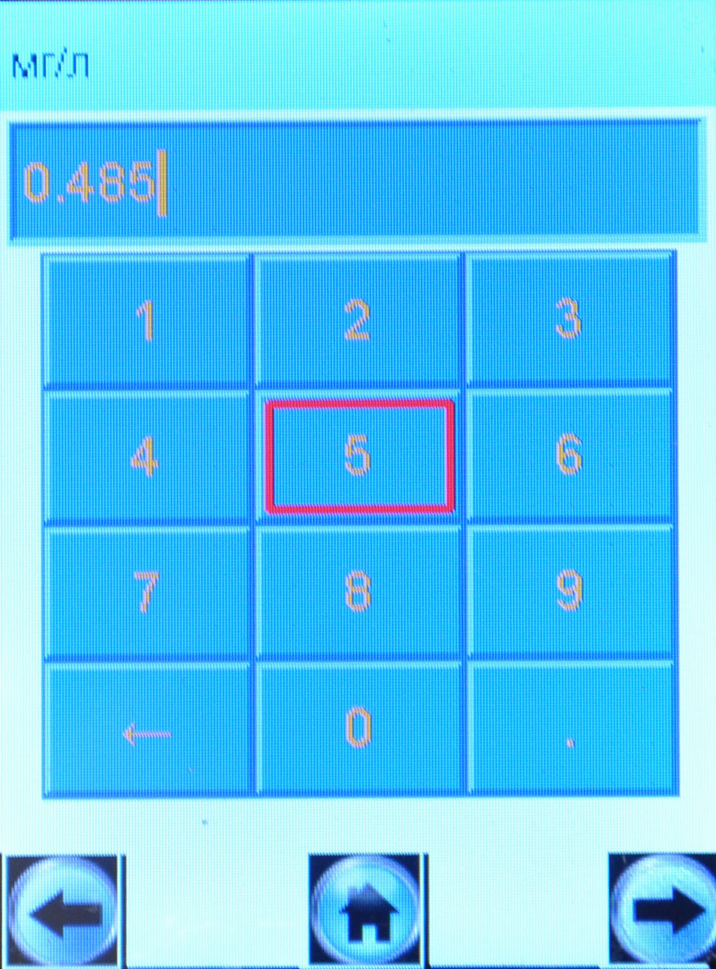
Here is a description of the problem. Open the calibration window and choose the wet calibration (1):
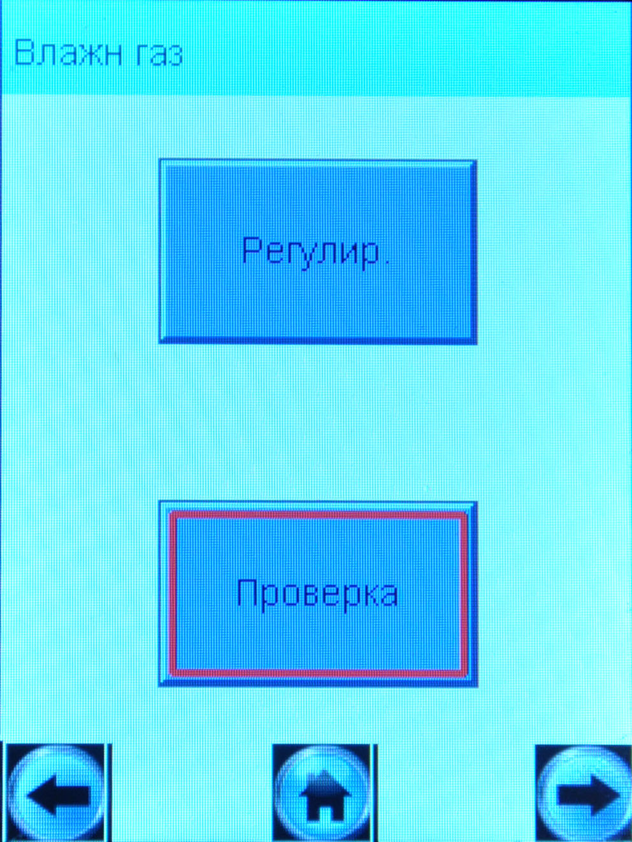
1
1
2

Pressing the button «Регулир.»:
And inputting concentration we’ve chosen for calibration (2).

Press the button “next window” and see:
The concentration we have entered before.
3
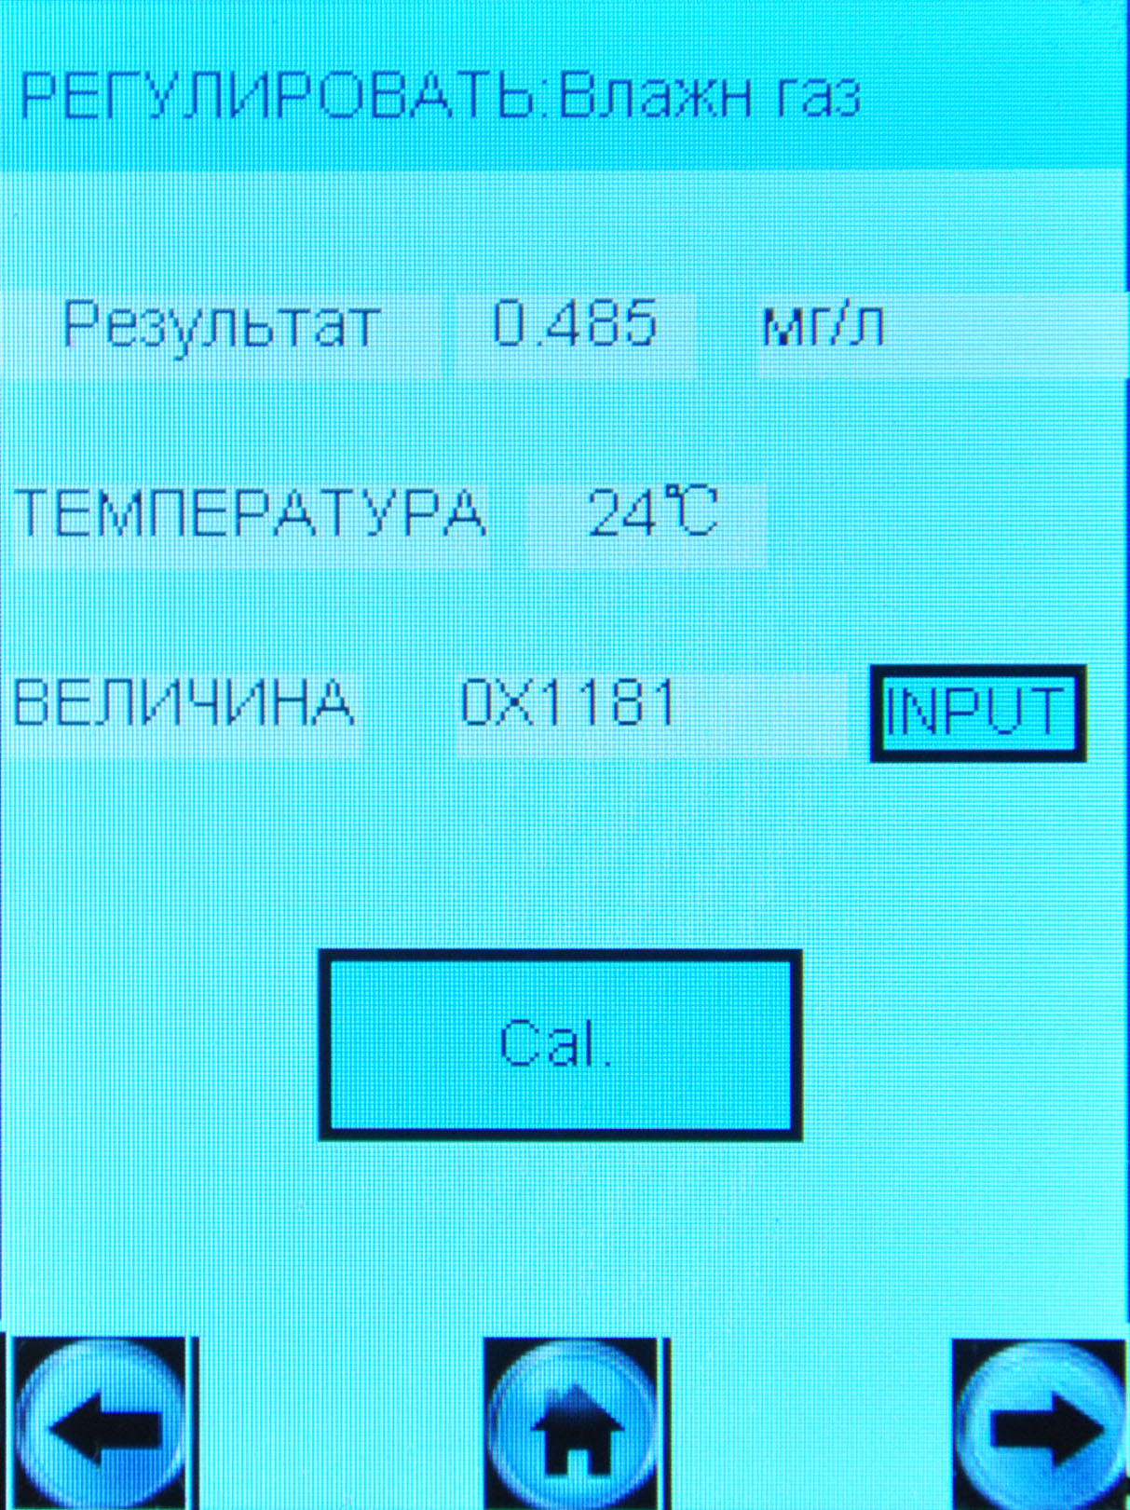

This window we use for the calibration by two ways: enter the coefficient manually and then press “input” or automatically by pressing the “Cal” button while we entering the standard gas
Problem: even we will not press “Input” button or “Calib” button the setting will be changed: the entered concentration will replace the concentration we used for calibration before.
What we want to have: When we enter the new concentration (for example 0,474 mg/L), the new concentration should be saved only after pressing “Input” or “Cal”:
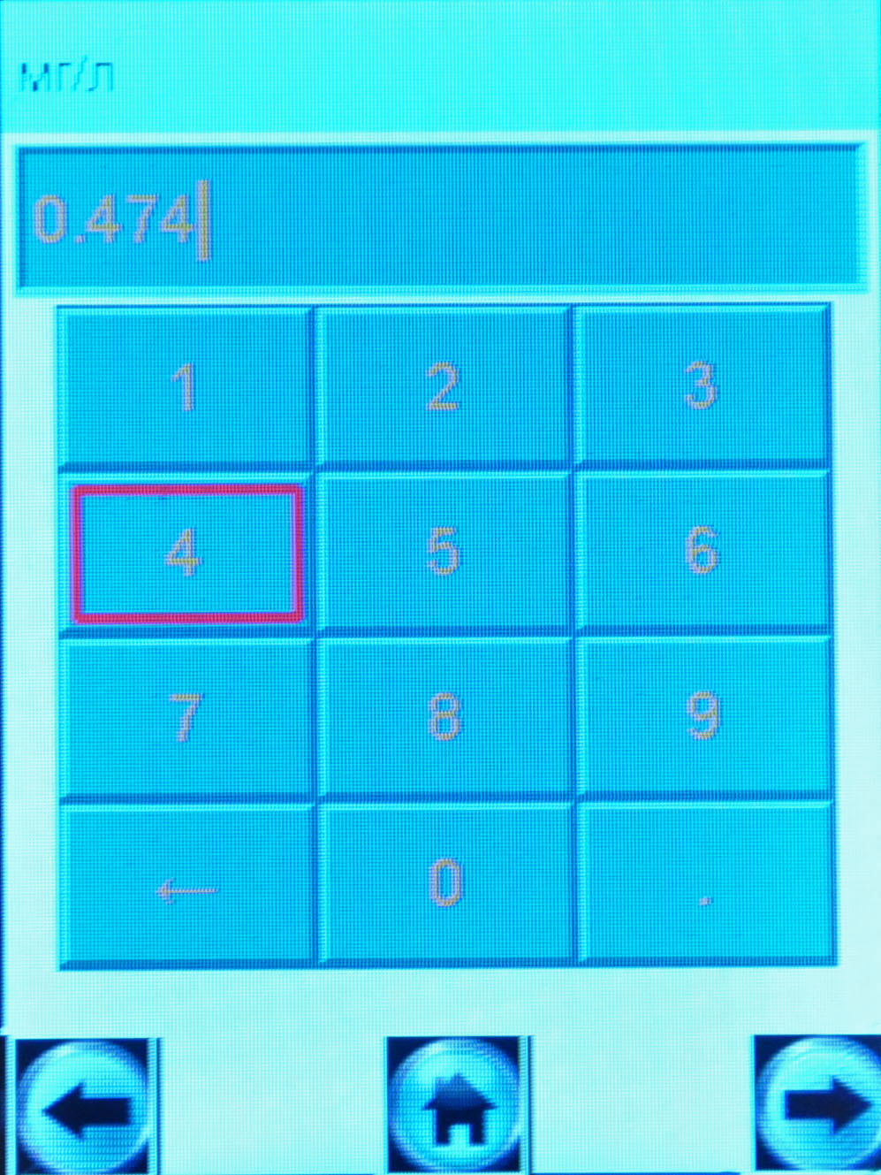

Then we press button “right”:
and see the nex winow:
This is the standard concentration we used for calibration before.

Then we can enter the coefficient manually and press “input” or enter the gas and press the “Cal” button. After that we will see:

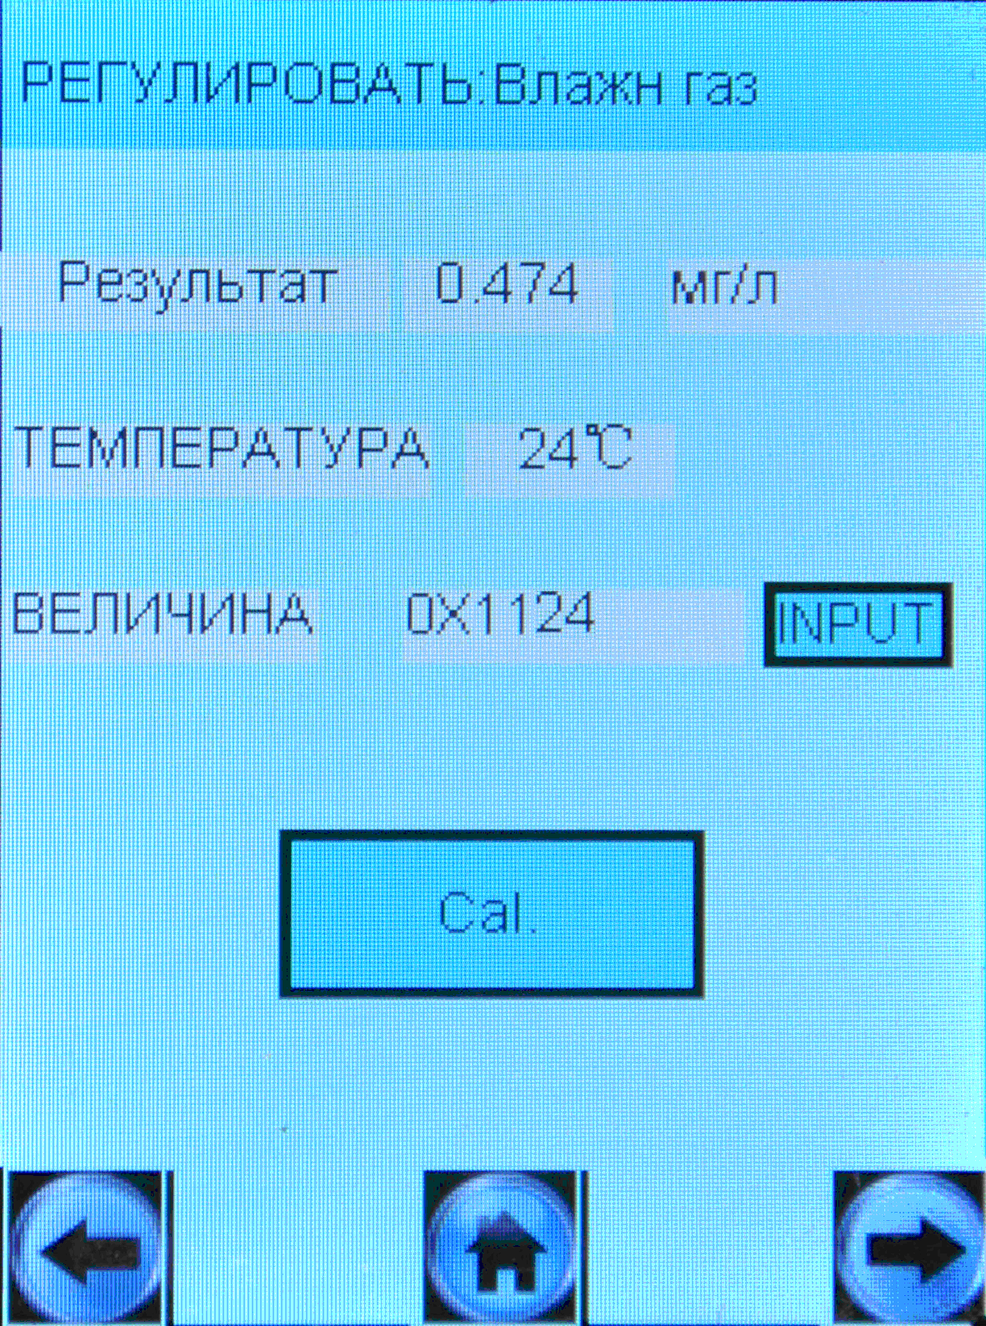
Standard concentration we used for new calibration procedure.
The new coefficient which is changed after calibration

If we do not complete calibration procedure (do not press any buttons) the settings will not be changed.

